Model 680
HIGH LEVEL ALARM - SHUT OFF
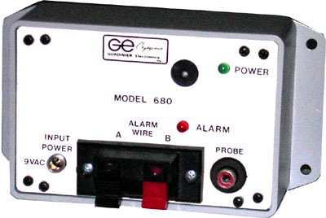
Model 680 control boxes are used in tandem with the Master Control box Model 2680. Comes complete with its own 9 volt AC wall transformer, thermistor sensor probe, audible horn, flashing LED.
THEORY OF OPERATION:
Each Model 680 is independently wired to each storage unit, using independent sensor probes and wall transformers.
The Model 680s' are also directly wired to each other using a single wire connecting to the Model 2680 Master Control Box. If any one of the Model 680's high level sensors come in contact with liquid nitrogen due to an overfill, the Model 2680 is activated along with the audible horn and flashing LED.
Model 680 control boxes will activate Model 2680 Master Control Box if:
1. Sensor is covered in LN2
2. Sensor comes unplugged
3. Sensor is damaged (open)
4. 9 volt AC wall transformer comes unplugged
5. Single alarm wire is disconnected
The Model 2680 via the single alarm wire, will activate an audible horn, remote relay, along with a power shut-off relay, activating a normally open bulk tank shut off valve.

