Model 677
SUPPLY TANK MONITOR (EYE LEVEL)
FEATURES:
• EYE LEVEL INDICATORS
• AUDIBLE PULSING HORN
• REMOTE RELAY OUTPUT
• PUSH TO "TEST" BUTTON
• FLASHING "EMPTY" LED PLUS HORN
• EASILY INSTALLED PROBE
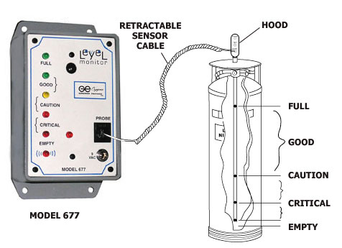
COMES COMPLETE WITH:
RETRACTABLE 7' PROBE CABLE
9 VOLT WALL TRANSFORMER

