Model 626
LN² LOW LEVEL ALARM Small Dewar Lid Size
FEATURES:
• Low Level Alarm
• Work Mute Button
• Progressive Audible Horn
• Press to Test Remote Relay (5 seconds)
• Flashing Alarm LED (normal no flashing)
• Universal 9 volt AC Wall Transformer (117 volt /OPTION 220 volt)
• Open Probe Alarm
• Shorted Probe Alarm
• Remote Alarm Output
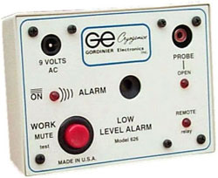
This unique controller has been designed to provide a complete working alarm system. This alarm provides protection during the time the probe is unplugged, or removed from the dewar. When the probe is removed from the dewar during a work function, simply press the work button. This will keep the alarm in a momentary standby mode (approximately 10 minutes). If the probe is not returned after 10 minutes, the alarm will slowly return to its full audible horn and activate the remote relay.
The Progressive Audible Horn allows the operator to remove the probe from the dewar without the unit going into an audible and a remote relay alarm. Pressing the Work/Mute button will lower the horn sound (which has been factory set). After 10 minutes the horn will gradually increase to maximum volume. This will alert the operator to place the probe back into the dewar, or press the Work/Mute button again.

