Model 610
BATTERY OPERATED LOW LEVEL ALARM
FEATURES:
• Built-in battery charger
• Continuous alarm (5 days on full battery charge)
• Universal 9 volt AC wall transformer/Option 220 volt
• Open or shorted probe protection
• Push to Test button (battery and alarm can both be tested at the same time)
• Easy Installation
• Compact size (3 1/4" x 5 1/2" x 1 3/4")
• Complete with mounting bracket to fit on the unit handle
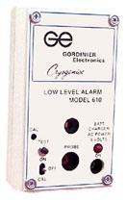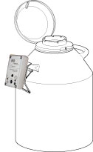
Model 610 is a battery operated liquid nitrogen (LN2) Low Level Alarm, providing up to 5 days of alarm on one (1) charge. This handy unit is also equipped with a built-in battery charger, a bracket designed to protect the unit during fill and provide easy access to the front plate.

