Model 410
AUTO FILL CONTROLLER
FEATURES:
• Single GREEN Normal LED indicating all systems are functioning properly
• Bright YELLOW Filling LED indicator
• Push to "START" and "STOP" buttons
• Manual "SPURT" button for defogging dewar during a work mode
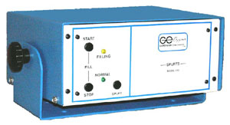
Model 410 is an automatic filling system for controlling liquid nitrogen with high and low level control.
The Model 410 uses a two (2) thermistor probe, which will give you the basic START FILL signal and the STOP FILLING signal indicated by the FILLING LED. 117 volt AC (Option 220 volt AC)

