Model 2279
KEEP COLD with Alarm FOR PIPELINE SYSTEMS
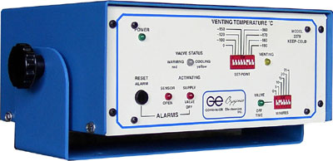
The Model 2279 is more than a "Keep Cold" controller maintaining a preselected temperature at the end of Vacuum Jacketed Pipeline (VJP) . Other functions include Stuck Valve detection, activating a main shut-off valve or alarm system. Also included are selectable temperature shut-off switches as well as time cycle switches. Bright indicator LED's show the status of all functions of the controller at a glance, such as Power ON, System Venting, Valve Off timer, Valve status temperature, sensor alarm, supply valve Off (Stuck Valve alarm).
Output ports include low voltage drivers for solid state relay along with remote relay receptacle. System operates on 117 volt AC 50/60 HZ or option 220 volt.
Control temperature is set with eight (8) position temperature select switch on the front plate. In the event of the pipeline running out of LN2 (supply), the Model 2279 will activate the shut-down circuit relay, in turn, turning "OFF" the main supply tanks normally open valve. In the event the pipelines cooling valve is stuck open, the unit will shut "OFF" the supply tanks main valve (normally open).

