Model 2065
MASTER BY-PASS CONTROLLER
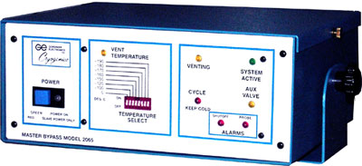
The Master By-Pass Controller has been designed to be used in conjunction with ancillary devices (slaves). Featuring the ability to orchestrate the filling of multiples of independent storage units with liquid on "demand".
Adding the Master By-Pass to a pipeline from a bulk supply will guarantee liquid filling. A temperature select switch on the front plate allows the operator to select one of eight (8) fixed temperature shut-off points.
The Master By-Pass is turned on by any of the ancillary devices, clearing the pipeline of gas. Once the temperature has been reached via its temperature probe, the Model 2065 will return the filling cycle back to each of the independent storage units.
The Master By-Pass system may be used for individual filling of each unit or may be setup to do "one fill" or "all fill". Doing an "ALL FILL" has been proven to be very economical.
The Model 2065 has the added feature of being used as a back-up system for mechanical refrigerators, by converting to a Keep Cold system after by-passing is completed.

