Model 2020
DUAL SUPPLY TANK SWITCHER
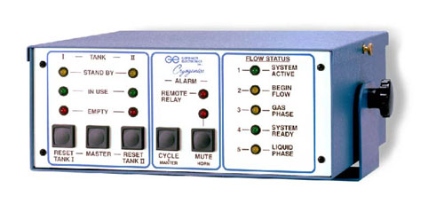
The Model 2020 is a unique automatic supply tank switching system that maintains a constant flow of liquid nitrogen. Activation of the Model 2020 is through the Converter Box, Model 4026, when connected to valves calling for liquid nitrogen. Model 4026 is used on valve voltages from 24VAC to 125VAC (optional 220VAC). For multiple filling using ancillary devices (slaves) contact Gordinier Electronics.
Once the 2020 is connected to the switch-over manifold, Model 2014 (1/4" or 1/2" valves), an LED Flow Status gage reflects the temperature of the manifold switch-over probe. Additional groups of LED's show the contents of each bank of supply tanks. Tank Switch- over occurs when the empty supply tank causes the warming of the manifold probe.
**All equipment is available in 117v or 220v

